ED RECEPTION
Maternity Patients SOP

A Face Sheet must be printed for every pregnant A&E patient, regardless of whether their A&E attendance is related to their pregnancy or not.
1 | If a patient tells you they are pregnant and/or you get the Maternity EPR Alert after booking a patient in - print a Face Sheet for that patient.
2 | Put the Face Sheet in Maternity – To Send folder
3 | Maternity folders must be checked every night and any Face Sheets in the To Send folder must be scanned and emailed. Scan and send to self and then forward on as below.  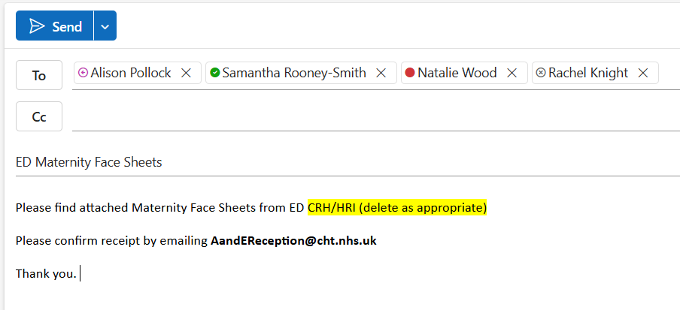  Email addresses are:  alison.pollock@cht.nhs.uk  samantha.rooney-smith@cht.nhs.uk  natalie.wood@cht.nhs.uk  rachel.knight@cht.nhs.uk
4 | Note the sent date and time on each Face Sheet and put in Maternity – Sent folder.
5 | Maternity Team will confirm receipt of the Face Sheets via the Reception group email account. Reception must dispose of (in the Confidential Waste) any Face Sheets that have been confirmed as received.

