ED RECEPTION
Fracture Clinic – Patient Seen at Out of Area A&E SOP

- Patients who have attended a different A&E but need a Fracture Clinic appointment with us do not need to book into our A&E. This includes patients seen at Emergency Departments abroad.

- The patient should only be booked into A&E if they require A&E treatment. If they simply need a Fracture clinic appointment, follow the below SOP.

1 | - Take the patient’s details, locate their patient record and note their MRN.  - If they have not attended our Trust before and do not have an MRN, use the Add Person Without Encounter function to create one for them.
2 | Email a referral to the Appointment Centre Phones Team using the format below.  It is important that you send your email with the Subject and details listed below so that the Phones Team can differentiate your referral from other Fracture Clinic requests. The Phones Team will only accept email referrals for patients seen out of area. If your email does not clearly state that they were seen out of area, the referral will be rejected.  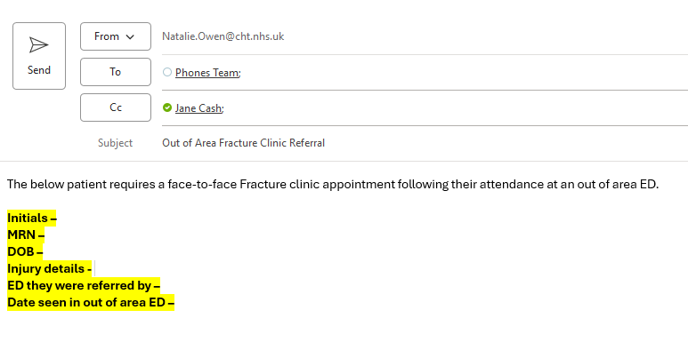
2 | The email addresses to send to are:  phones.team@cht.nhs.uk and  jane.cash@cht.nhs.uk
3 | Ensure that the information you enter is accurate.

