Paediatric ED Attendance Reports

Must be completed every Night, after Midnight, at both sites
1 | Open DA2 (Explorer Menu)  Double click Explorer Reports, Main Menu, ED Reports, ED Paediatric Attendance Report
2 | Click printer icon next to Output drop down, select Printer, CHFTSecurePrint, OK
3 | Select Calderdale and Huddersfield NHS Foundation Trust from the Trust drop down menu.
4 | Enter Reporting Period Dates and Times:  - The Start Date and the Finish Date must BOTH be the day before (i.e. date your Night shift started on)  - The Start Time must be 00:01 and the Finish Time must be 23:59.  Select CRH or HRI, then ED CRH or ED HRI, as appropriate. Select Execute.  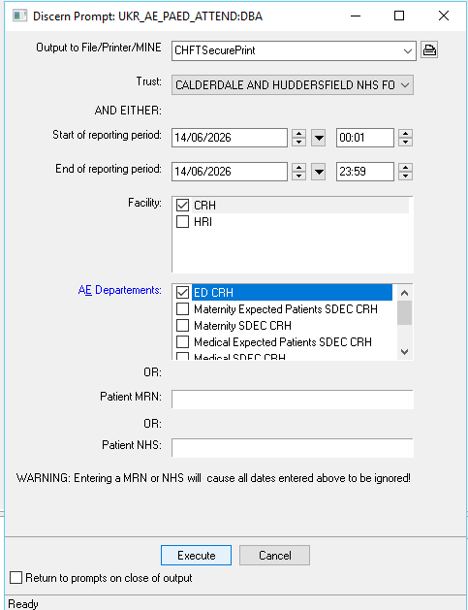
5 | The below message will be displayed once the report has been run and sent to the printer.  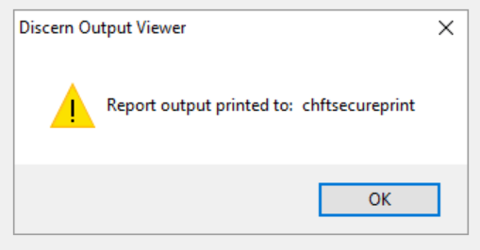  Allow a minimum of 10 minutes before collecting the printing. Due to the size of the report, there can often be a small delay in all pages arriving at the printer.
6 | After printing the reports, refresh your print list to check for further documents having arrived.
7 | Sort through the printed reports, stapling together each individual child’s report.
8 | Organise the reports by the area the child’s home address is in, then post out to the below Children’s services.  Calderdale home addresses (All HX postcodes plus HD6 and OL14)  Calderdale Admin Team, Horsefall House, Mulcture Hall Road, Halifax, HX1 1SP  South Kirklees (Huddersfield) home addresses (All HD postcodes except HD6)  Children’s Admin Team, Slaithwaite Town Hall, Care Lane, Slaithwaite, Huddersfield, HD7 5AF  Bradford home addresses (All BD postcodes)  Bradford Child Health Department, Level 3, New Mill, Saltaire, Bradford, BD18 3LD  Any other UK area  Send to the GP listed on the child’s report  Area outside of UK  Discard in confidential waste  NB – Please send all reports for each service together. (i.e send all Calderdale reports together, send all Bradford reports together). Do not send reports for the same service individually.
9 | If you encounter technical issues and cannot print the reports –  - Check that you have followed all steps correctly  - Ask your colleague to attempt to print them  - Ask colleagues at opposite site to print them for you  - You MUST escalate any issues to Reception Team Leader, Valerie Cartwright

